Day-7 Task

1. Write a constructor for the class Movie, which takes a String representing the title of the movie, a String representing the studio, and a String representing the rating as its arguments, and sets the respective class properties to these values.

**Coding**

class Movie {

constructor(title, studio, rating = "PG") {

this.title = title;

this.studio = studio;

this.rating = rating;

}

getPG = function (arr) {

return arr.filter((m) => {

return m.rating === "PG";

});

};

}

let movie1 = new Movie("Casino Royale", "Eon Productions", "PG13");

let movie2 = new Movie("Avengers", "Disney", "PG15");

let movie3 = new Movie("Fight Club", "Dalmount", "PG18");

let movie4 = new Movie("Avengers End Game", "Disney");

const arr = [movie1, movie2, movie3, movie4];

let a= movie1.getPG(arr);

console.log(arr);

Output:

console.log(movie3);

Movie { title: 'Fight Club', studio: 'Dalmount', rating: 'PG18' }

1. The constructor for the class Movie will set the class property rating to "PG" as default when no rating is provided

**Coding**

console.log(movie4);

**Output:**

Movie { title: 'Avengers End Game', studio: 'Disney', rating: 'PG' }

c) Write a method getPG, which takes an array of base type Movie as its argument, and returns a new array of only those movies in the input array with a rating of "PG". You may assume the input array is full of Movie instances. The returned array need not be full.

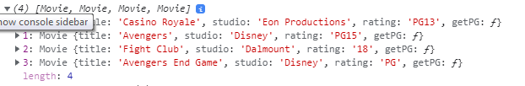

d) Write a piece of code that creates an instance of the class Movie with the title “Casino Royale”, the studio “Eon Productions”, and the rating “PG­13”

console.log(movie1);

##### Output:

Movie {

title: 'Casino Royale',

studio: 'Eon Productions',

rating: 'PG13' }